Matéria: Língua Inglesa
Prof.: Jahnien de Almeida Ribeiro
Curso: Engenharia de Software
Semestre: 1° semestre
Aluno: Thiago Rafael C. T. da Silva
AT10
1. Leitura & compreensão
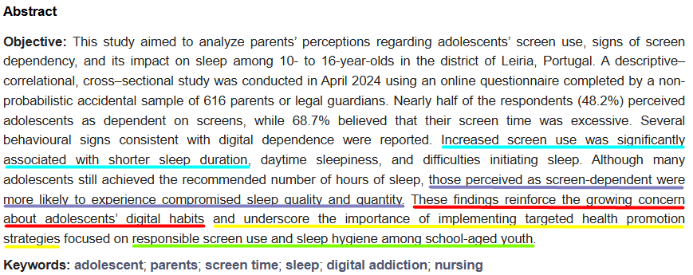
- Leiam e sublinhem ideias/frases que poderiam ser transformadas para o futuro (por exemplo previsões, implicações futuras, sugestões de pesquisa futura).

2. Identificação de possíveis frases de futuro
- Mesmo que no Abstract não haja will, identifique trechos onde faz sentido expressar intenção futura.
- Exemplos possíveis: implicações para políticas futuras, necessidade de estudos posteriores, impacto esperado, etc.
  - “These findings reinforce the growing concern about adolescents’ digital habits”
  - “…underscore the importance of implementing targeted health promotion strategies…”
  - “…focused on responsible screen use and sleep hygiene among school-aged youth.”
  - “Increased screen use was significantly associated with shorter sleep duration, daytime sleepiness, and difficulties initiating sleep.”
  - “Those perceived as screen-dependent were more likely to experience compromised sleep quality and quantity.”
  - “These findings reinforce the growing concern (…) and underscore the importance of implementing (…) strategies.”
  - Todo o trecho final:
“These findings (…) underscore the importance of implementing targeted health promotion strategies…”
3. Reescrita: transformar em simple future
- Para cada trecho selecionado, escreva uma frase afirmativa no simple future.
- Exemplo: “The study will inform guidelines for screen time regulation.”
- Depois converta em negativa: “The study __________ …”
- E em interrogativa: “ ___________…?”
Trecho 1: Ideia original:
“These findings reinforce the growing concern about adolescents’ digital habits.”
- Afirmativa (simple future)
- “These findings will increase the concern about adolescents’ digital habits.”
- Negativa
- “These findings will not increase the concern about adolescents’ digital habits.”

- Interrogativa
- “Will these findings increase the concern about adolescents’ digital habits?”

Trecho 2: Ideia original:
“…underscore the importance of implementing targeted health promotion strategies…”

- Afirmativa
- “Health promotion strategies will be implemented to address adolescents’ screen use and sleep habits.”

- Negativa
- “Health promotion strategies will not be implemented to address adolescents’ screen use and sleep habits.”

- Interrogativa
- “Will health promotion strategies be implemented to address adolescents’ screen use and sleep habits?”

Trecho 3: Ideia original:
“Increased screen use was associated with shorter sleep duration…”

- Afirmativa
- “Increased screen use will continue to affect adolescents’ sleep duration.”

- Negativa
- “Increased screen use will not continue to affect adolescents’ sleep duration.”

- Interrogativa
- “Will increased screen use continue to affect adolescents’ sleep duration?”

Trecho 4: Ideia original:
“Those perceived as screen-dependent were more likely to experience compromised sleep…”

- Afirmativa
- “Screen-dependent adolescents will experience compromised sleep quality and quantity.”

- Negativa
- “Screen-dependent adolescents will not experience compromised sleep quality and quantity.”

- Interrogativa
- “Will screen-dependent adolescents experience compromised sleep quality and quantity?”

